Lab Evaluation-1 CB.SC.U4CSE23144 SANDHEEP G S
5/2/2026

- About the Use case:
#. Use Cases
The application is versatile and serves multiple stakeholder groups:

A. Special Education & Inclusive Classrooms
Teachers can use the explorer as a "Pre-Trip" activity. By projecting the scenery on a screen, the class can discuss what they expect to see and hear during an upcoming excursion, significantly reducing student anxiety.

B. Occupational & Speech Therapy
Therapists use the interactive sceneries to practice:
- **Vocabulary Building**: Identifying objects in context (e.g., "stethoscope" in a hospital).
- **Social Stories**: Role-playing social interactions based on the visual cues in the scenery.
- **Sensory Regulation**: Teaching students to use the "Settings" panel to manage their own sensory input (self-advocacy).

C. Domestic & Caregiver Support
Parents can sit with their children to explore a "New School" scenery, helping ease the transition to a new grade or building. The "Reduce Motion" and "Calm" settings allow for a tailored experience that fits the child's specific needs.

Technology Stack:
## 3. Detailed Technology Stack
The project is built using a "Gold Standard" modern React stack, prioritizing accessibility, performance, and developer experience.
### **Frontend Infrastructure**
- **React 18 (Hooks-Based)**: Utilizes the latest React features, including `useState`, `useReducer`, `useEffect`, and `useRef` for a highly responsive UI.
- **TypeScript (Strict Mode)**: Ensures the entire codebase is type-safe, preventing common runtime errors and providing self-documenting code.
- **Vite**: The build engine, providing instantaneous Hot Module Replacement (HMR) for a smooth development workflow.

### **UI & Design System**
- **Tailwind CSS**: A utility-first engine used for all styling. It ensures the application is fully responsive and adheres to a strict design token system.
- **shadcn/ui (Radix Primitives)**: Provides the foundation for complex UI components (Tabs, Dialogs, Selects) while ensuring they meet the highest accessibility (WAI-ARIA) standards.
- **Lucide React**: A lightweight icon library used for intuitive visual navigation.

### **State & Data Management**
- **Context API**: High-level application state (Settings, Navigation, User Difficulty) is managed via a centralized `AppContext`.
- **TanStack Query (React Query)**: Orchestrates data state, ensuring that scenery information is cached and managed efficiently.
- **React Router v6**: Handles complex navigation, including the recent addition of Tutorial and Contribution modules.

### **Educational Modules**
- **React Mastery Tutorial**: A dedicated learning area within the app that uses Functional/Class component examples to teach React fundamentals.
- **Advanced Contribution Portal**: An extended form-based module demonstrating complex state management, dynamic lists (React Keys), and focus management (Refs).

PURPOSE AND VISION:
The **Sensory Scenery Explorer** is an innovative digital platform designed to provide a "sensory-first" exploration experience. The primary vision is to empower neurodivergent learners and individuals with sensory processing sensitivities by offering a safe, predictable, and customizable environment to explore the world.
### Strategic Goals:
- **Desensitization & Preparation**: Mitigate "fear of the unknown" by allowing users to virtually visit potentially overwhelming locations (like a bustling hospital or a noisy classroom) before they go in person.
- **Cognitive Mapping**: Help users build a mental map of different environments, identifying key objects and sounds at their own pace.
- **Skill Acquisition**: Use gamified learning to teach users about the specific features and expectations of different social and physical spaces.

Concept | Code Proof/Screenshot
Function component | 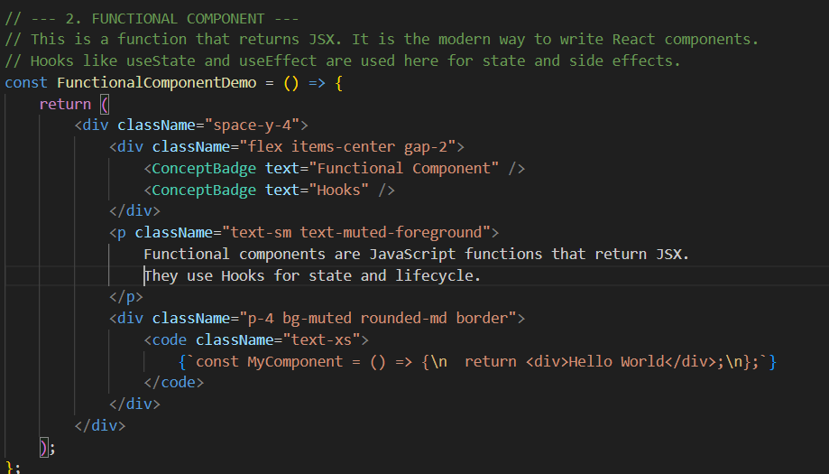
Class Component | 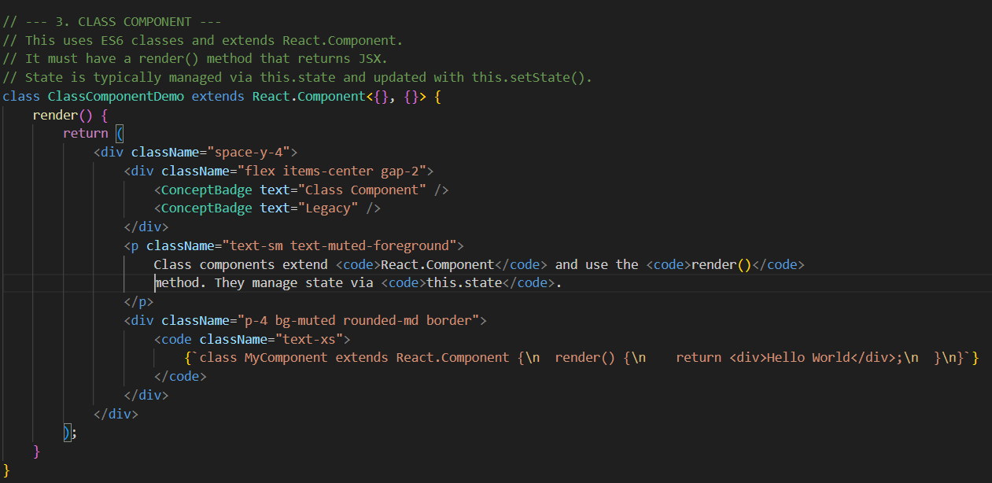
Event | 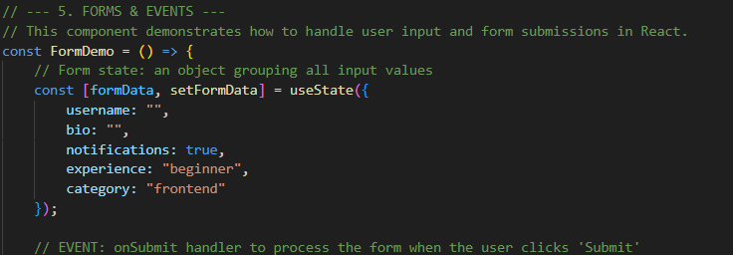
State Management | 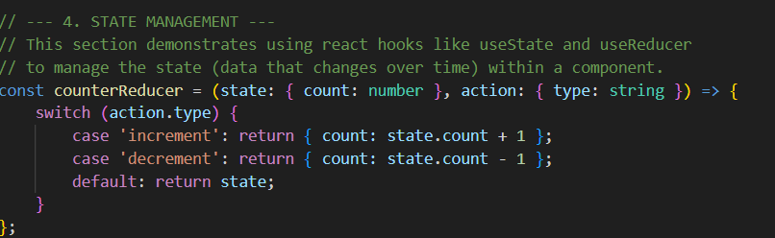
Stateless Component | 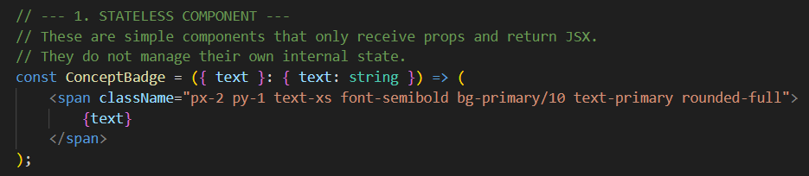
Forms | 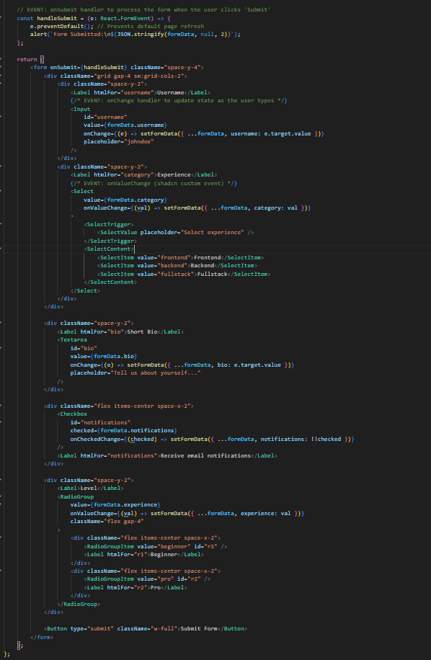
Routing | 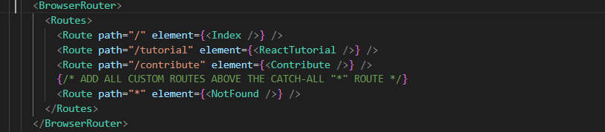
Hooks | 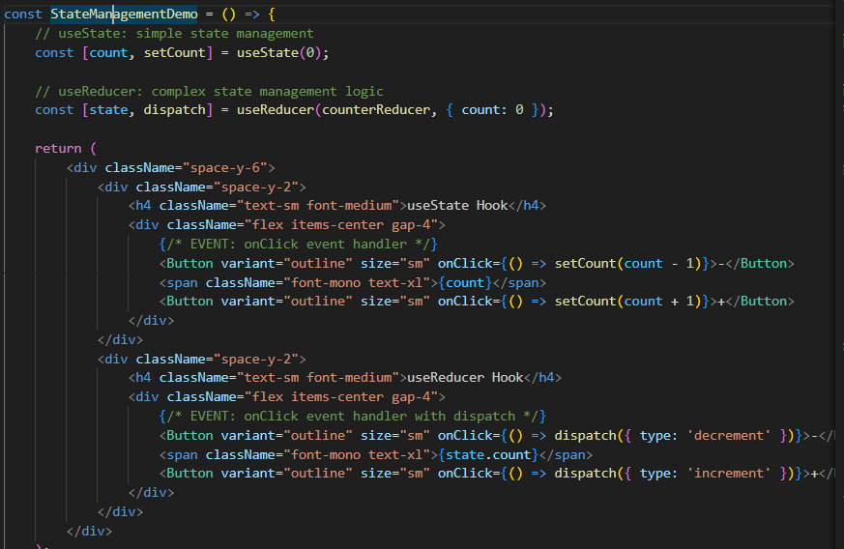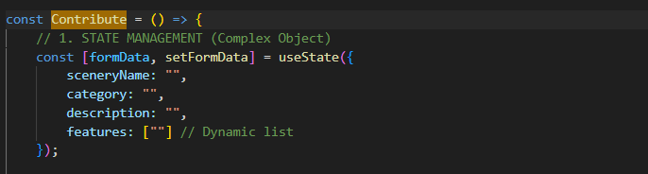

UI Aspects--- 10 Marks
Concepts Implemented from React JS---30 marks
Extension Level---10 Mark

